Submit a Public Comment & Map to Protect Houston Community College (HCC) District IV

BACKGROUND: The Houston Community College System is currently divided into nine single-member (represented by one HCC board member) districts. Every 10 years, when the U.S. Census records population changes, HCC districts are redrawn. HCC District IV, which includes the historic, Black communities, Third Ward and Sunnyside, is being redrawn and engulfed into HCC District III. For equitable representation on the HCC Board, submit the map with your public comment (both found below) to protect HCC District IV’s boundaries.

CALL TO ACTION/SUBMISSION DEADLINES:
- Opportunity to make your voice heard in person at District IV Redistricting Community Forum
  - January 17, 2023, 6:30 PM at 3018 Emancipation Ave 77004
- By the February 28 deadline, click here to submit your feedback (proposed map and written public comment) on the redistricting process to Houston Community College. You can also email hcc.redistricting@hccs.edu
  - “Persons providing proposed maps and comments must identify themselves by full name and home address and provide a phone number and, if available, an email address in case the Board wishes to follow up on your proposed map and/or comments to obtain additional information about submitted maps.”

HOW TO/PUBLIC COMMENT (Written or Talking) POINTS:

Dear HCC Board of Trustees,
My name is ___________. I live in ___________ neighborhood (for example, I have lived in the Third Ward for twenty years), and/or I work at _________ organization. I am writing to encourage you to accept the map I have submitted along with this comment in order to restore the Third Ward in the Houston Community College System and preserve a historically African American community.
- Now, choose two-three of the points below to include in your comment. Feel free to add your own language to embellish the points below.
Thank you for your time and consideration,
Your Name

- The Third Ward and Sunnyside communities are becoming more diverse, gentrified, and exclusive of economically disadvantaged families as it relates to housing, high-performing schools, and economic opportunity.
- HCC is the only system with a district map that separates Third Ward.
  - HISD, City Council District D, Complete Communities, and Third Ward Superneighborhood maintain District maps that keep Third Ward intact. HCC is the only map that differs, removing Alabama St and everything east of it from District IV and placing it in District III.
- Third Ward does not require two representatives from HCC to make decisions on their behalf.
  - To collaborate with HISD, City Council District D, Complete Communities, or Greater Third Ward Super Neighborhood, it should not require conversations with two Trustees from two different districts to make a decision. This could result in making exclusive decisions instead of inclusive decisions.
- The HCC map that divides Third Ward provides the legal fodder that other single-member municipalities can use to build a case to redraw lines that can change representation not reflective of the community culture, values, or history.
- Dividing Third Ward has the potential for further community fragmentation and could perpetuate development in a direction not representative of the community.

Map below to submit to HCC Board to vote on along with your comments. A PDF copy of the map to submit is located here.

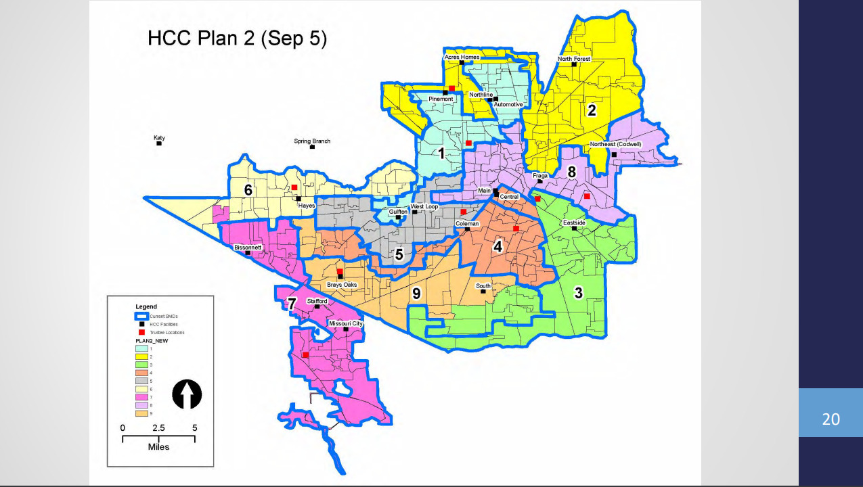

Additional Information:
- The final redistricting map will be announced as the final decision regarding HCC redistricting in April 2023.
- Click here to view a Powerpoint with more details.
- Click here to learn about HCC District IV Trustee Dr. Reagan Flowers.
- To view past HCC Board of Trustee meetings, click here.

